**Assignment No:-1**

Name:-Suryawanshi Sangramsingh Sambhaji

Batch:-April Date:-23/4/2024

**1. Write a Java program to print 'Hello' on screen and your name on a separate line.**

public class HelloAssignment

{

public static void main(String[]args)

{

System.out.println("Hello");

System.out.println("Suryawanshi Sangramsingh sambhaji");

}

}

**Output:**

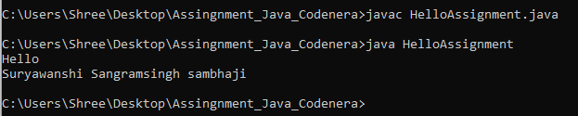

**2. Write a Java program to print the sum of two numbers.**

public class SumAssignment

{

public static void main(String[]args)

{

int a = 74;

int b = 36;

System.out.println("Sum of Two Numbers:"+(a+b));

}

}

**Output:**

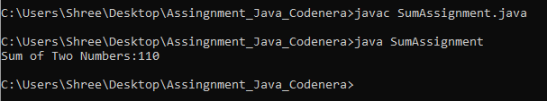

**3. Write a Java program to divide two numbers and print them on the screen.**

public class DivideAssignment

{

public static void main(String[]args)

{

int a = 50;

int b = 3;

System.out.println("Division of two numbers:"+(a/b));

}

}

**Output:**

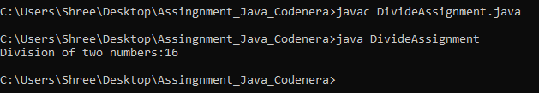

**4. Write a Java program to print the results of the following operations.**

public class OperationAssignment

{

public static void main(String[]args)

{

System.out.println(-5 + 8 * 6);

System.out.println((55+9) % 9);

System.out.println(20 + -3*5 / 8);

System.out.println(5 + 15 / 3 * 2 - 8 % 3);

}

}

**Output:**

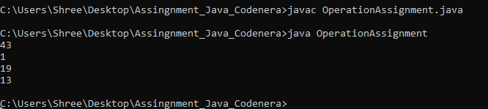

**5. Write a Java program that takes two numbers as input and displays the product of two numbers.**

import java.util.Scanner;

public class ProductAssignment

{

public static void main(String[]args)

{

Scanner sc = new Scanner(System.in);

System.out.print("Input Frist Number:");

int a = sc.nextInt();

System.out.print("Input Second Number:");

int b = sc.nextInt();

System.out.println("25 x 5="+(a*b));

}

}

**Output:**

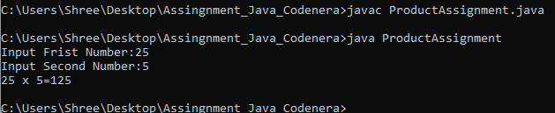

**6. Write a Java program to print the sum (addition), multiply, subtract, divide and remainder of two numbers.**

import java.util.Scanner;

public class ArithmaticAssignment

{

public static void main(String[]args)

{

Scanner sc = new Scanner(System.in);

System.out.print("Input Frist Number:");

int a = sc.nextInt();

System.out.print("Input Second Number:");

int b = sc.nextInt();

System.out.println("125 + 24 ="+(a+b));

System.out.println("125 - 24 = "+(a-b));

System.out.println("125 x 24 = "+(a*b));

System.out.println("125 / 24 = "+(a/b));

System.out.println("125 mod 24 = "+(a%b));

}

}

**Output:**

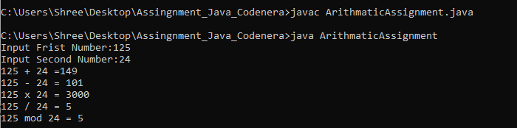

**7. Write a Java program that takes a number as input and prints its multiplication table up to 10.**

import java.util.Scanner;

public class MultiplicationTableAssignment

{

public static void main(String[]args)

{

Scanner sc = new Scanner(System.in);

System.out.print("Input Number:");

int a = sc.nextInt();

System.out.println("8 x 1 = "+(a*1));

System.out.println("8 x 2 = "+(a*2));

System.out.println("8 x 3 = "+(a*3));

System.out.println("8 x 4 = "+(a*4));

System.out.println("8 x 5 = "+(a*5));

System.out.println("8 x 6 = "+(a*6));

System.out.println("8 x 7 = "+(a*7));

System.out.println("8 x 8 = "+(a*8));

System.out.println("8 x 9 = "+(a*9));

System.out.println("8 x 10 = "+(a*10));

}

}

**Output:**

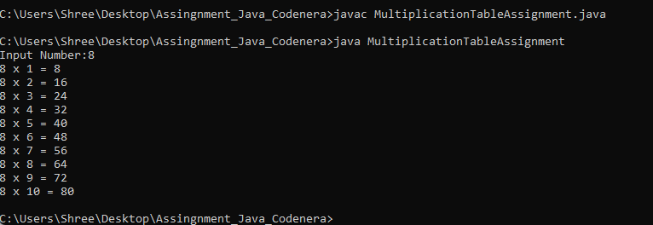

**8. Write a Java program to display the following pattern.**

public class PatternAssignment

{

public static void main(String[]args)

{

System.out.println(" J a v v a ");

System.out.println(" J a a v v a a ");

System.out.println(" J J aaaaa V V aaaaa ");

System.out.println(" JJ a a V a a ");

}

}

**Output:**

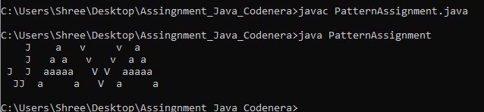

**9. Write a Java program to compute the specified expressions and print the output.**

public class ExpressionAssignment

{

public static void main(String[]args)

{

System.out.println(((25.5 * 3.5 - 3.5 * 3.5) / (40.5 - 4.5)));

}

}

**Output:**

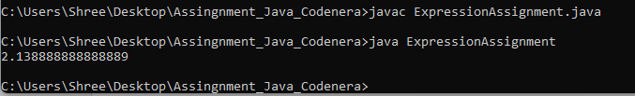

**10. Write a Java program to compute a specified formula.**

public class FormulaAssignment

{

public static void main(String[]args)

{

System.out.println(4.0 * (1 - (1.0/3) + (1.0/5) - (1.0/7) + (1.0/9) - (1.0/11)));

}

}

**Output:**

